Point Inside a Region

Definition
# Source: AI Source: Provided by: [Data Path: Persons Table -> ID Column: 1, Name_En Column: Motasem Essam] -> From: [ChatGPT] on [7/25/2026]
A Point Inside a Region is a point that lies in the interior of a specified geometric region, without lying on its boundary.
If $P$is a point and $R$is a region, the containment relationship is written as:
$$P∈int⁡\left(R\right)$$
or, when the context makes the interior clear:
$$\boxed{P\text{ is inside }R}$$
The key distinction is that an inside point is not on the boundary of the region.
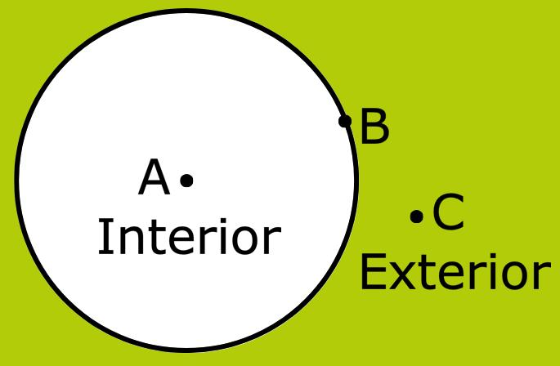
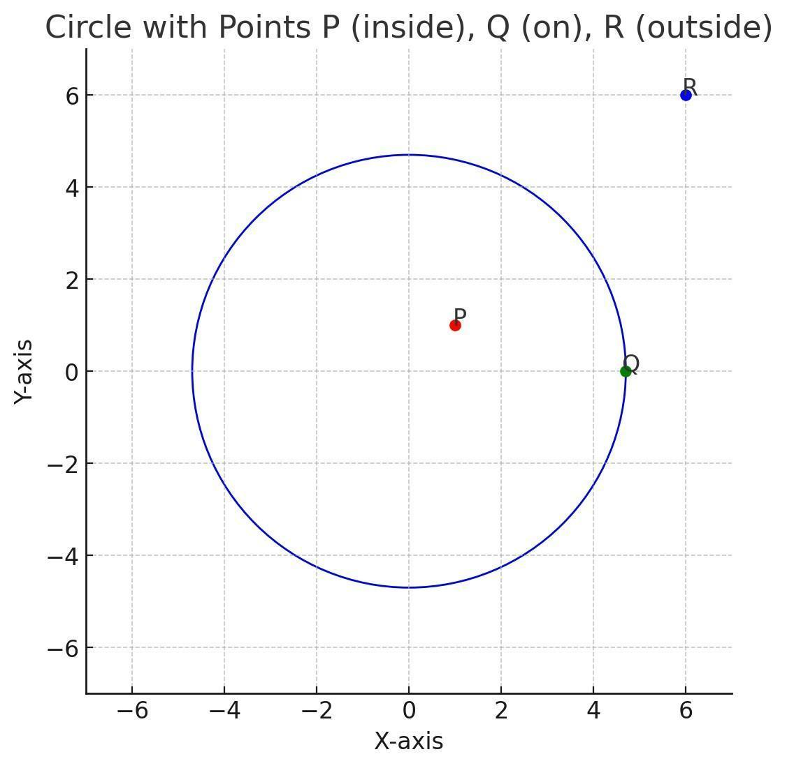
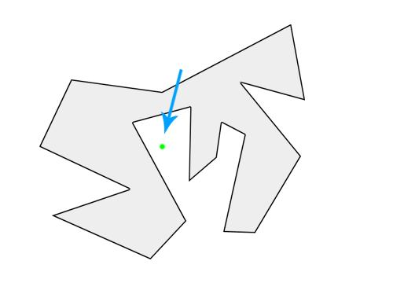
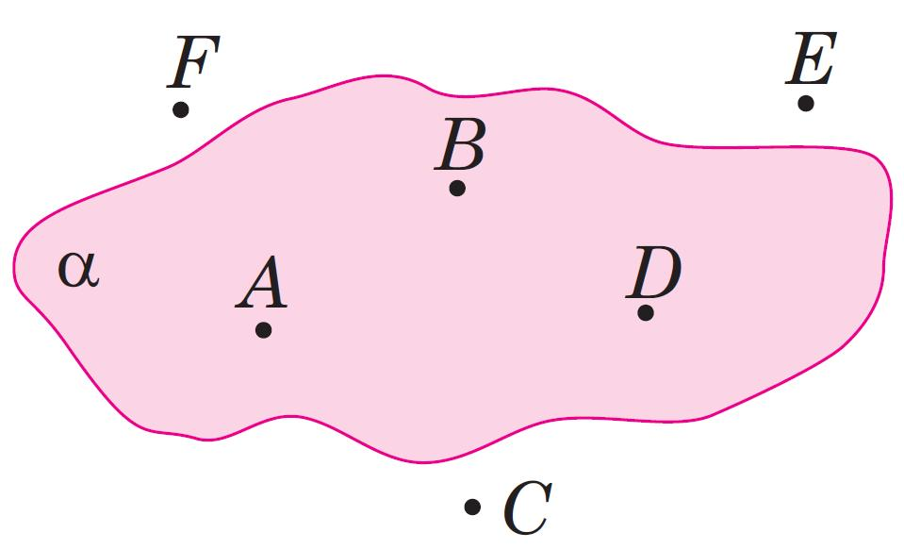
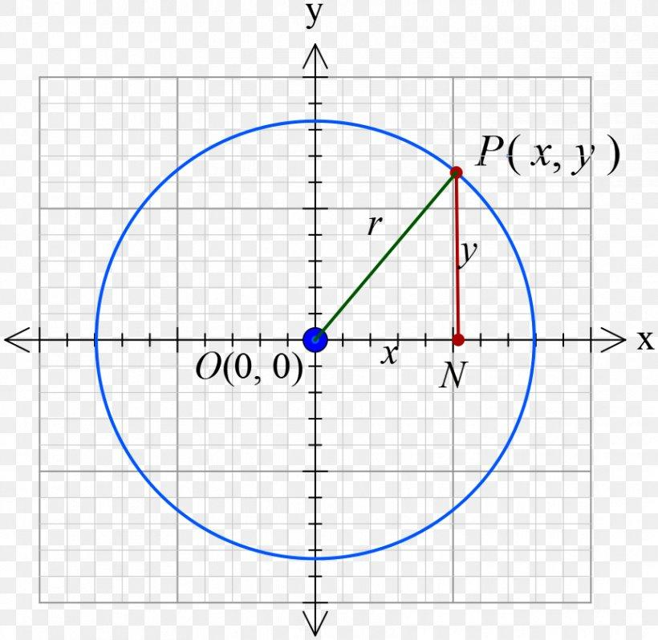
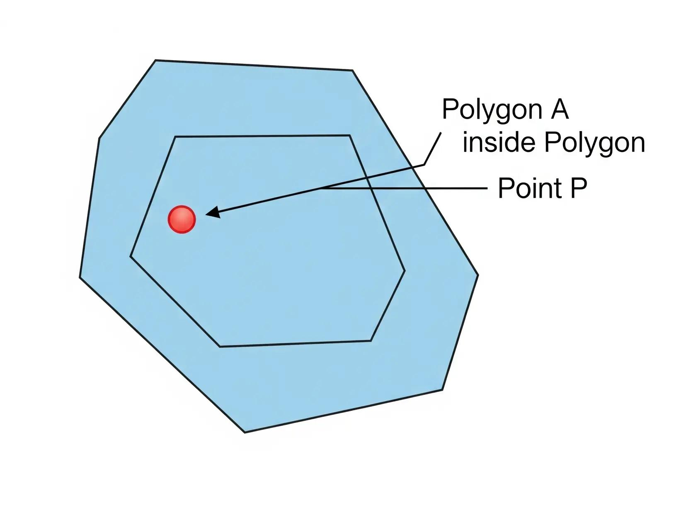

Fundamental Concept
# Source: AI Source: Provided by: [Data Path: Persons Table -> ID Column: 1, Name_En Column: Motasem Essam] -> From: [ChatGPT] on [7/25/2026]
A geometric region can be divided into three important positional parts:
- Interior — points inside the region.
- Boundary — points forming the edge of the region.
- Exterior — points outside the region.
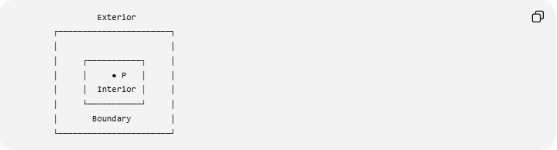
Exterior
┌───────────────────────┐
│ │
│ ┌───────────┐ │
│ │ ● P │ │
│ │ Interior │ │
│ └───────────┘ │
│ Boundary │
└───────────────────────┘
For a point strictly inside:
$$\boxed{P∈int⁡\left(R\right)}$$

Interior, Boundary, and Exterior
# Source: AI Source: Provided by: [Data Path: Persons Table -> ID Column: 1, Name_En Column: Motasem Essam] -> From: [ChatGPT] on [7/25/2026]
Consider a circular region:
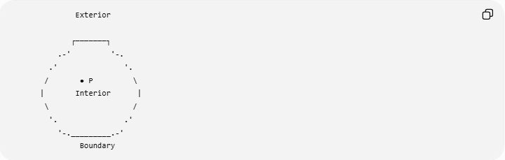
Exterior

┌───────┐
.-' '-.
.' '.
/ ● P \
| Interior |
\ /
'. .'
'-._________.-'
Boundary
There are three different possibilities:
Point inside
$$P∈int⁡\left(R\right)$$
Point on the boundary
$$P∈∂R$$
Point outside
$$P∉R$$
when $R$denotes the closed region.

Mathematical Representation
# Source: AI Source: Provided by: [Data Path: Persons Table -> ID Column: 1, Name_En Column: Motasem Essam] -> From: [ChatGPT] on [7/25/2026]
The exact mathematical representation depends on the shape of the region.
For example, consider a circular region centered at the origin with radius $r$.
Interior of the Circle
The points strictly inside the circle satisfy:
$$\boxed{x^{2}+y^{2}<r^{2}}$$
Boundary
The points on the circumference satisfy:
$$\boxed{x^{2}+y^{2}=r^{2}}$$
Exterior
The points outside satisfy:
$$\boxed{x^{2}+y^{2}>r^{2}}$$
Therefore:
$$\boxed{\left\{\begin{matrix}x^{2}+y^{2}<r^{2} & \text{inside} \\ x^{2}+y^{2}=r^{2} & \text{on boundary} \\ x^{2}+y^{2}>r^{2} & \text{outside}\end{matrix}\right.}$$

Example: Point Inside a Circular Region
# Source: AI Source: Provided by: [Data Path: Persons Table -> ID Column: 1, Name_En Column: Motasem Essam] -> From: [ChatGPT] on [7/25/2026]
Consider the circular region:
$$x^{2}+y^{2}<25.$$
This represents the interior of a circle with:
$$r=5.$$
Let:
$$P=\left(3 , 2\right).$$
Calculate:
$$3^{2}+2^{2}=9+4=13.$$
Since:
$$13<25,$$
the point lies inside the region.
Therefore:
$$\boxed{P∈int⁡\left(R\right)}$$

Example: Point on the Boundary
# Source: AI Source: Provided by: [Data Path: Persons Table -> ID Column: 1, Name_En Column: Motasem Essam] -> From: [ChatGPT] on [7/25/2026]
Consider:
$$x^{2}+y^{2}=25.$$
Let:
$$P=\left(3 , 4\right).$$
Then:
$$3^{2}+4^{2}=9+16=25.$$
Therefore:
$$\boxed{P∈∂R}$$
The point is on the boundary, not strictly inside.

Example: Point Outside
# Source: AI Source: Provided by: [Data Path: Persons Table -> ID Column: 1, Name_En Column: Motasem Essam] -> From: [ChatGPT] on [7/25/2026]
Let:
$$P=\left(6 , 2\right).$$
Then:
$$6^{2}+2^{2}=36+4=40.$$
Since:
$$40>25,$$
the point is outside the circular region.
Therefore:
$$\boxed{P∉R}$$
for the closed disk, and it is not an interior point.

Point Inside a Polygonal Region
# Source: AI Source: Provided by: [Data Path: Persons Table -> ID Column: 1, Name_En Column: Motasem Essam] -> From: [ChatGPT] on [7/25/2026]
A point can also lie inside a polygonal region.
For example:
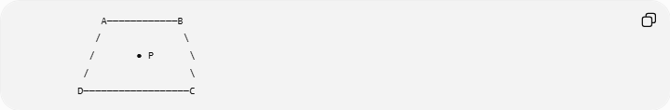
A────────────B
/ \
/ ● P \
/ \
D──────────────────C
If $P$lies strictly within the polygon, then:
$$\boxed{P∈int⁡\left(ABCD\right)}$$
The point does not have to be at the geometric center of the polygon.

Point Inside a Rectangle
# Source: AI Source: Provided by: [Data Path: Persons Table -> ID Column: 1, Name_En Column: Motasem Essam] -> From: [ChatGPT] on [7/25/2026]
For a rectangle with opposite corners:
$$\left(x_{min} , y_{min}\right)$$
and:
$$\left(x_{max} , y_{max}\right),$$
a point:
$$P=\left(x , y\right)$$
is strictly inside when:
$$\boxed{x_{min}<x<x_{max}}$$
and:
$$\boxed{y_{min}<y<y_{max}}$$
For a rectangle from $\left(0 , 0\right)$to $\left(10 , 6\right)$, point:
$$P=\left(4 , 3\right)$$
is inside because:
$$0<4<10$$
and:
$$0<3<6.$$
Therefore:
$$\boxed{P∈int⁡\left(R\right)}$$

Point Inside a Triangle
# Source: AI Source: Provided by: [Data Path: Persons Table -> ID Column: 1, Name_En Column: Motasem Essam] -> From: [ChatGPT] on [7/25/2026]
A point can also be inside a triangular region.
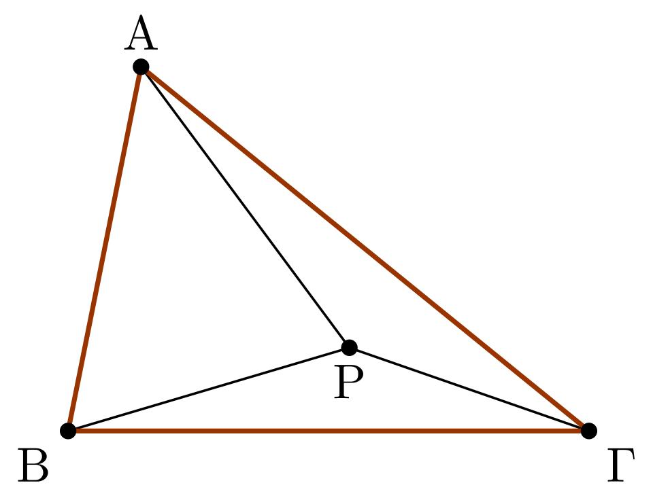
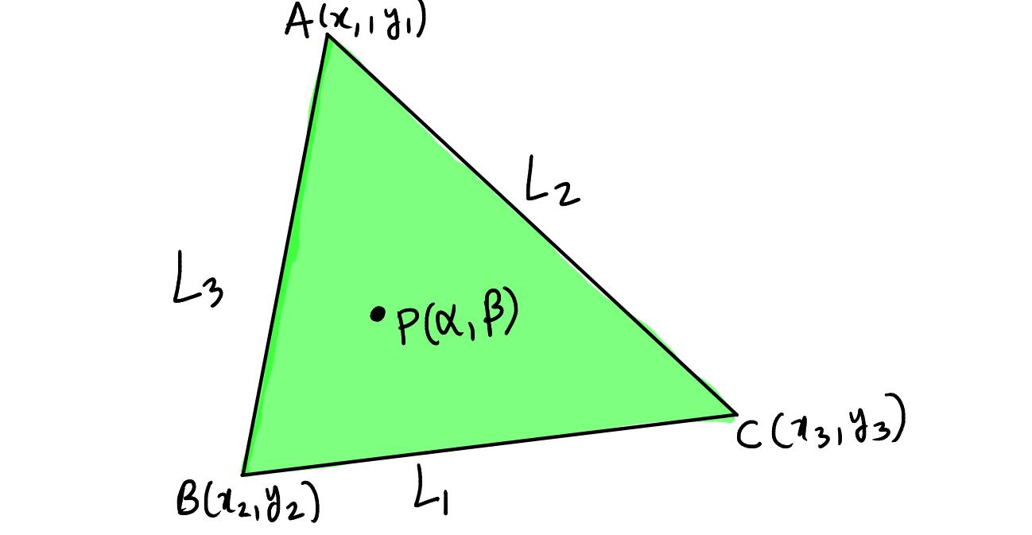
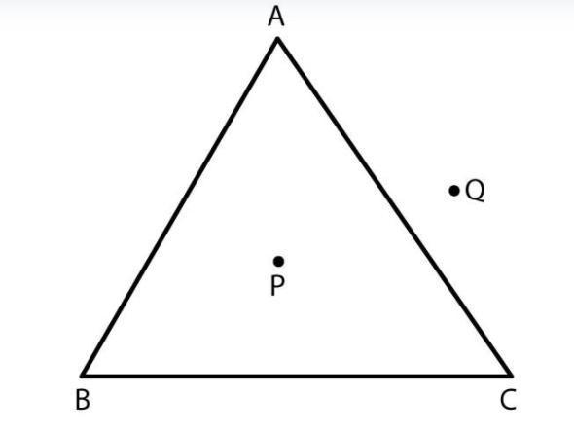
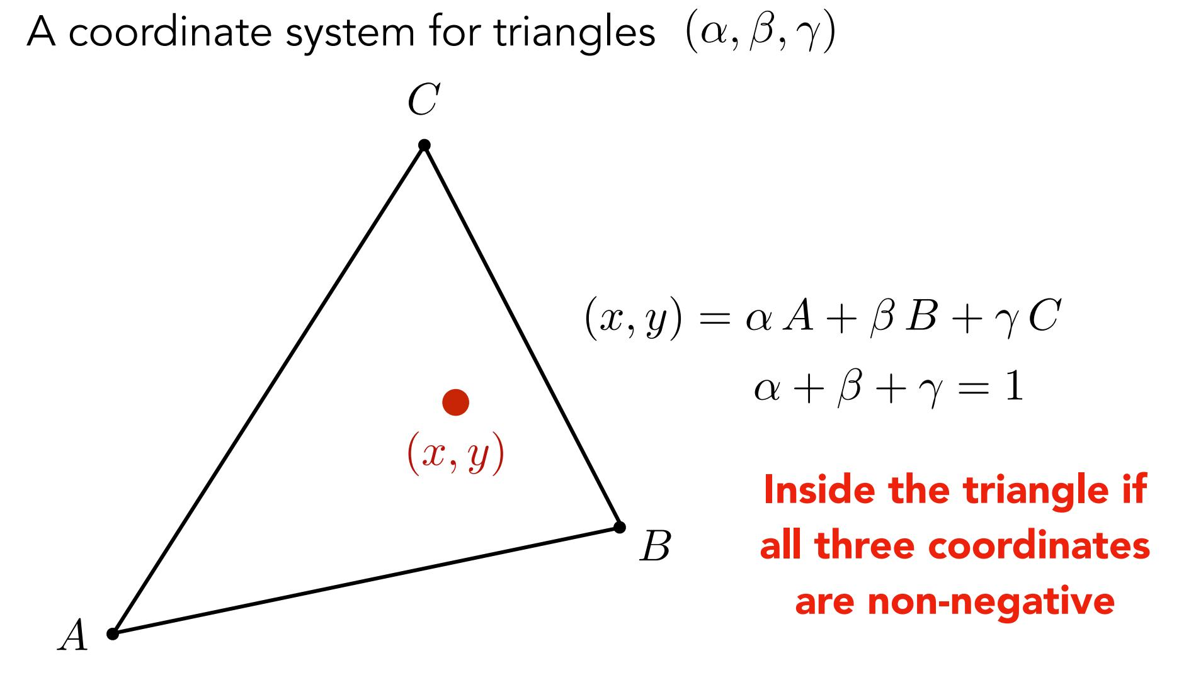
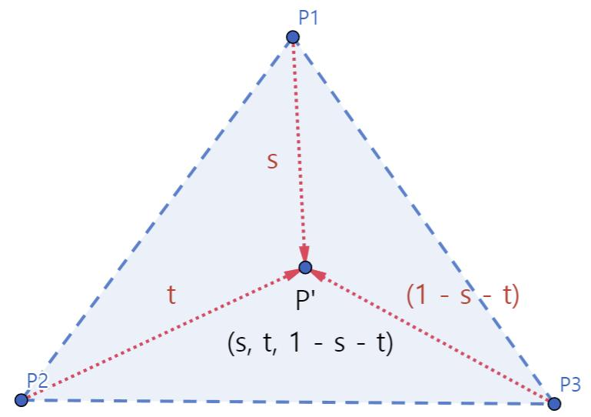
For triangle $ABC$, a point $P$is strictly inside the triangle when it lies within all three sides and is not on any side.
One useful representation is:
$$P=αA+βB+γC$$
where:
$$α>0, β>0, γ>0$$
and:
$$α+β+γ=1.$$
These are called barycentric coordinates.

Point Inside a General Region
# Source: AI Source: Provided by: [Data Path: Persons Table -> ID Column: 1, Name_En Column: Motasem Essam] -> From: [ChatGPT] on [7/25/2026]
The word region is broader than a particular shape.
A region may be:
- circular,
- rectangular,
- triangular,
- polygonal,
- elliptical,
- irregular,
- bounded,
- or unbounded.
Therefore, there is no single universal equation for every region.
The general concept is:
$$\boxed{P∈int⁡\left(R\right)}$$
meaning that $P$is an interior point of $R$.

Open and Closed Regions
# Source: AI Source: Provided by: [Data Path: Persons Table -> ID Column: 1, Name_En Column: Motasem Essam] -> From: [ChatGPT] on [7/25/2026]
This distinction is important.
Open Region
An open region contains its interior points but excludes its boundary.
For example:
$$x^{2}+y^{2}<r^{2}.$$
The boundary:
$$x^{2}+y^{2}=r^{2}$$
is not included.
Closed Region
A closed region includes both the interior and its boundary.
For example:
$$x^{2}+y^{2}≤r^{2}.$$
Here:
- $x^{2}+y^{2}<r^{2}$→ inside
- $x^{2}+y^{2}=r^{2}$→ boundary
- $x^{2}+y^{2}>r^{2}$→ outside
Thus, a point can belong to a closed region while still being on its boundary, but a point strictly inside must not be on the boundary.

Point Inside vs Point on the Boundary
# Source: AI Source: Provided by: [Data Path: Persons Table -> ID Column: 1, Name_En Column: Motasem Essam] -> From: [ChatGPT] on [7/25/2026]
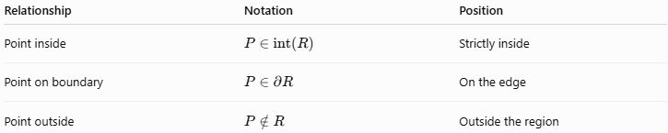
Relationship | Notation | Position
Point inside | $$P∈int⁡\left(R\right)$$ | Strictly inside
Point on boundary | $$P∈∂R$$ | On the edge
Point outside | $$P∉R$$ | Outside the region
This distinction is particularly important when working with inequalities.

Point Inside a Region vs Point in a Plane
# Source: AI Source: Provided by: [Data Path: Persons Table -> ID Column: 1, Name_En Column: Motasem Essam] -> From: [ChatGPT] on [7/25/2026]
These concepts are related but different.
Point in a Plane
$$P∈Π$$
means that $P$belongs to an entire infinite plane.
Point Inside a Region
$$P∈int⁡\left(R\right)$$
means that $P$lies within a specified part of a plane or space.
For example:
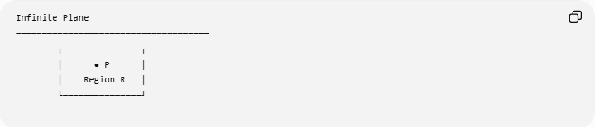
Infinite Plane
─────────────────────────────────────
┌───────────────┐
│ ● P │
│ Region R │
└───────────────┘
─────────────────────────────────────
The region is a subset of the plane:
$$R⊆Π.$$
Therefore, if:
$$P∈int⁡\left(R\right),$$
then:
$$P∈Π.$$

Point Inside a Region vs Point on a Surface
# Source: AI Source: Provided by: [Data Path: Persons Table -> ID Column: 1, Name_En Column: Motasem Essam] -> From: [ChatGPT] on [7/25/2026]
A surface describes a set of points forming a geometric surface.
A region generally describes an area or volume with an interior.
For example, for a circle:
$$x^{2}+y^{2}=r^{2}$$
describes the circumference, while:
$$x^{2}+y^{2}<r^{2}$$
describes its interior region.
Thus:
$$\boxed{\text{Boundary}≠\text{Interior}}$$
This distinction is especially important when discussing circles, disks, spheres, and solids.

Point Inside a Region vs Point in a Solid
# Source: AI Source: Provided by: [Data Path: Persons Table -> ID Column: 1, Name_En Column: Motasem Essam] -> From: [ChatGPT] on [7/25/2026]
In two-dimensional geometry:
$$P∈int⁡\left(R\right)$$
describes a point inside an area.
In three-dimensional geometry, a point can be inside a solid:
$$P∈int⁡\left(V\right).$$
For example, for a sphere:
Spherical surface
$$x^{2}+y^{2}+z^{2}=r^{2}$$
Interior of the sphere
$$x^{2}+y^{2}+z^{2}<r^{2}$$
Solid sphere
$$x^{2}+y^{2}+z^{2}≤r^{2}.$$

Topological Interpretation
# Source: AI Source: Provided by: [Data Path: Persons Table -> ID Column: 1, Name_En Column: Motasem Essam] -> From: [ChatGPT] on [7/25/2026]
In mathematics, an interior point is a point for which there exists a sufficiently small neighborhood around the point that remains completely inside the region.
If $P$is an interior point of $R$, there exists some radius $ε>0$such that:
$$B\left(P , ε\right)⊂R.$$
In simple terms:
You can move a small distance in any direction from $P$without immediately leaving the region.
This is why a point on the boundary is not an interior point: moving slightly outward takes you outside the region.

Examples in Different Shapes
# Source: AI Source: Provided by: [Data Path: Persons Table -> ID Column: 1, Name_En Column: Motasem Essam] -> From: [ChatGPT] on [7/25/2026]
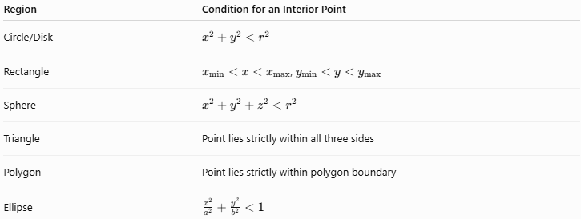
Region | Condition for an Interior Point
Circle/Disk | $$x^{2}+y^{2}<r^{2}$$
Rectangle | $x_{min}<x<x_{max}$, $y_{min}<y<y_{max}$
Sphere | $$x^{2}+y^{2}+z^{2}<r^{2}$$
Triangle | Point lies strictly within all three sides
Polygon | Point lies strictly within polygon boundary
Ellipse | $$\frac{x^{2}}{a^{2}}+\frac{y^{2}}{b^{2}}<1$$

Real-World Applications
# Source: AI Source: Provided by: [Data Path: Persons Table -> ID Column: 1, Name_En Column: Motasem Essam] -> From: [ChatGPT] on [7/25/2026]
Point-inside-region containment is used in:
- Maps: determining whether a location lies inside a country, city, or administrative boundary.
- Computer graphics: determining whether a pixel lies inside a shape.
- Geographic Information Systems (GIS): point-in-polygon analysis.
- Robotics: determining whether a robot is inside a permitted area.
- Architecture: checking whether a point lies inside a floor plan.
- Engineering: determining whether a measurement location lies within a designed region.
- Game development: collision and boundary detection.
- Computer vision: determining whether a detected point lies inside an object or region.

Relationship with Related Concepts
# Source: AI Source: Provided by: [Data Path: Persons Table -> ID Column: 1, Name_En Column: Motasem Essam] -> From: [ChatGPT] on [7/25/2026]
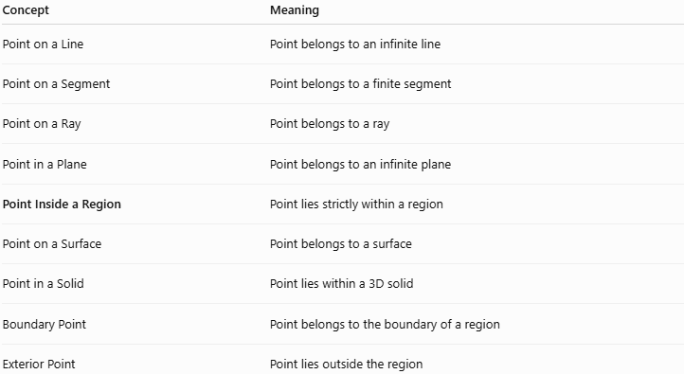
Concept | Meaning
Point on a Line | Point belongs to an infinite line
Point on a Segment | Point belongs to a finite segment
Point on a Ray | Point belongs to a ray
Point in a Plane | Point belongs to an infinite plane
Point Inside a Region | Point lies strictly within a region
Point on a Surface | Point belongs to a surface
Point in a Solid | Point lies within a 3D solid
Boundary Point | Point belongs to the boundary of a region
Exterior Point | Point lies outside the region

Key Points
# Source: AI Source: Provided by: [Data Path: Persons Table -> ID Column: 1, Name_En Column: Motasem Essam] -> From: [ChatGPT] on [7/25/2026]
- A Point Inside a Region lies strictly in the interior of the region.
- The standard mathematical notation is:
$$\boxed{P∈int⁡\left(R\right)}.$$
- An interior point is not on the boundary.
- A region can be circular, triangular, rectangular, polygonal, elliptical, or irregular.
- For a circular region:
$$x^{2}+y^{2}<r^{2}$$
represents its interior.
- Equality:
$$x^{2}+y^{2}=r^{2}$$
represents the boundary.
- Greater than:
$$x^{2}+y^{2}>r^{2}$$
represents the exterior.
- An open region excludes its boundary, while a closed region includes its boundary.
- A region is generally a subset of a larger geometric space, such as a plane.
- Inside is different from on the boundary and outside.
- Point-in-region containment is fundamental in geometry, coordinate geometry, topology, GIS, computer graphics, and computational geometry.

Conclusion
# Source: AI Source: Provided by: [Data Path: Persons Table -> ID Column: 1, Name_En Column: Motasem Essam] -> From: [ChatGPT] on [7/25/2026]
Point Inside a Region describes a point that lies strictly within the interior of a specified geometric region. Unlike a boundary point, an interior point has a small neighborhood around it that remains within the region. The concept provides the foundation for distinguishing interior, boundary, and exterior points and is widely used in geometric containment, coordinate geometry, spatial analysis, computer graphics, GIS, and computational geometry.

